PERSONAL INFORMATION | Vu Dinh Tuan
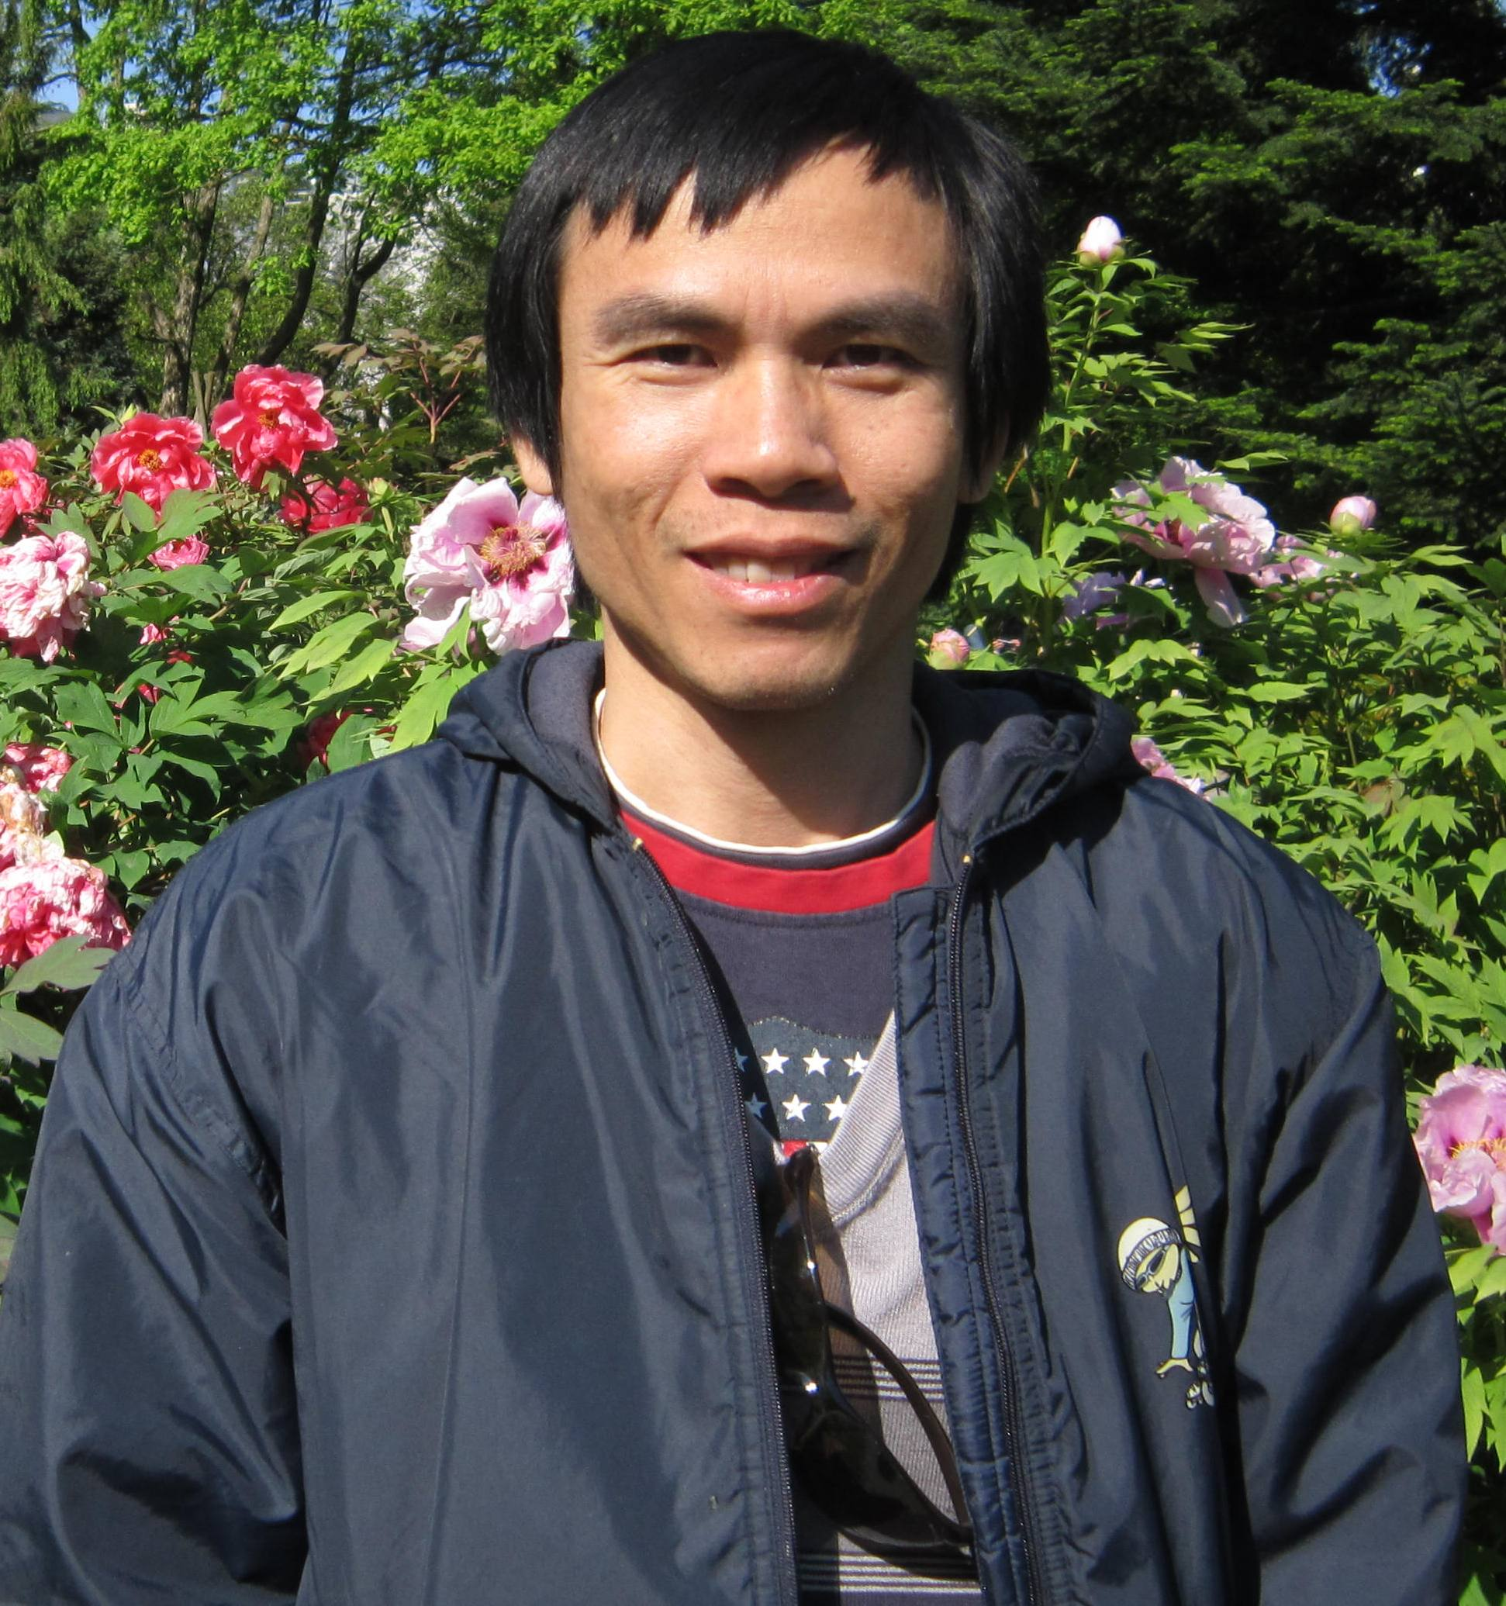 |   Institute 380a, Hohenheim Universitat, 13 Garben, Stuttgart, 70599, Germany;  Institute for Agricultural Environment, Phu Do, Hanoi Vietnam

49 176 2752 6723 (Germany), 84 912 179 806 (Vietnam)

vudinhtuan2001@yahoo.com; tuan.vu@uni-hohenheim.de

State personal website(s)

Skype: tuan.vudinh
 | Sex male | Date of birth 03/09/1974 | Nationality Vietnamese

WORK EXPERIENCE

8/2014 – to date | Researcher
8/2014 – to date | Institute for Agricultural Environment, Phu Do, Nam Tu Liem, Hanoi, Vietnam. http://www.iae.vn/vien-moi-truong-nong-nghiep.htm
8/2014 – to date | - Proposal writing: Effect of using Biochar for paddy rice on soil fertility and carbon sequestration, submitted to ADB  - Proposal editing: Impact of socio-transformation processes on agriculture, aquaculture and ecological functions of a wetland basin. Application for Funding from WLE Greater Mekong.  - Lecture in training course: Mitigation and adaptation strategy in cropping areas
8/2014 – to date | Business or sector: Public research institute

WORK EXPERIENCE

4/2009 – 7/2014 | PhD student, researcher
4/2009 – 7/2014 | Hohenheim University, Institute of Plant Production and Agroecology in Tropics and Subtropics, 13 Garben, Stuttgart, 70599, Germany
4/2009 – 7/2014 | - Involved in the project “Fostering rural development and environmental sustainability through integrated soil and water conservation systems in the uplands of Northern Vietnam”  Key responsibilities:  - Coordinating field-work activities including on-farm experiments in Son La, NW Vietnam  - Local management of administrative and science works  - Reporting results to donors and presenting at international, national conferences  - Organizing meetings, workshops within framework of the project  - Supervising (2 students) and co-supervising (3 students)  - Webpage: https://www.uni-hohenheim.de/projekt/fostering-rural-development-and-environmental-sustainability-through-integrated-soil-and-water-conservation-systems-in-the-uplands-of-northern-vietnam
4/2009 – 7/2014 | Business or sector: Public university

WORK EXPERIENCE

12/1996 – 3/2009  2007  2006  2005  2002-2006  2002  2000-2001  1998-2000  1996-1999 | Researcher
 | Institute for Soil and Fertilizer, Duc Thang, Bac Tu Liem, Hanoi, Vietnam
Delivered overview on agriculture status of Hanoi city being used as input for modelling P fluxes for environmental sanitation concepts. Fund provided by Swiss National Science Foundation through NCCR North-South program.
“Determination of N and P fertilizer efficiency for vegetable and coffee using labelled ¹⁵N and ³²P” project funded by MARD-Vietnam. Responsible for project coordination, data analysis and report compilation.
“Environmental Protection and Pig production” a project funded by ASIAPROECO programme of the European Commission. Responsible for local coordination of a work package, and data analysis and report compilation.
Sustainable farming at the rural-urban interface-An integrated knowledge-based approach for nutrient and water recycling in small-scale farming systems in peri-urban areas of China and Vietnam, a project funded by European Commission. Responsibilities: supporting administration and local coordination, responsible for PRA survey and local ecological knowledge acquisition.
Conducted bioassay experiments to determine toxic responses of maize to Cu and Zn concentrations in soil and assisted with soil and plant sampling for determination of baseline metal concentrations in soils and plant in North Vietnam within framework of the project in collaboration with CSIRO ‘Impact of heavy metals on sustainability of fertilization and waste recycling in peri-urban and intensive agriculture in South-East Asia - LWR1/1998/199’.
Compiling data and performing Land Use Planning and Analysis Systems using multiple goal linear programming for various scales (regional-district) in North Vietnam.
Determining fertilizer use efficiency for paddy rice and maize.
Assessing land use suitability at various locations in North Vietnam (Bac Giang, Nam Dinh, Tuyen Quang), series of projects funded by National Environment Agency. Responsibilities: Household survey and soil sampling.
 | Business or sector: Public research institute
EDUCATION AND TRAINING

10/2004 – 10/2006 | MSc | 7
10/2004 – 10/2006 | Hanoi Agricultural University, Trau Qui, Gia Lam, Hanoi, Vietnam
10/2004 – 10/2006 | Principal subject: Soil science  Thesis title: “An application of GLEAMS model to study phosphorous balance in intensive vegetable systems on Eutric Fluvisols”

EDUCATION AND TRAINING

9/1991 – 12/1995 | Engineer of agronomy | 6
9/1991 – 12/1995 | Hanoi Agricultural University, Trau Qui, Gia Lam, Hanoi, Vietnam
9/1991 – 12/1995 | Principal subject: Soil and fertilizer.  Skill acquired: Soil laboratory, field management for paddy rice, groundnut, field and green house experiment
PERSONAL SKILLS

Mother tongue(s) | Vietnamese
Other language(s) | UNDERSTANDING |  | SPEAKING |  | WRITING
Other language(s) | Listening | Reading | Spoken interaction | Spoken production
English | C1/2 | C1/2 | B1/2 | B1/2 | C1/2
 | TOEIC 820
Levels: A1/2: Basic user - B1/2: Independent user - C1/2 Proficient user
Common European Framework of Reference for Languages

Communication skills | - good communication skills in English gained through my involvement in international cooperative projects and contacts

Organisational / managerial skills | - project coordination: i was responsible for a team of 8 persons within framework of EnBW project for 4 years

Job-related skills | - High proficiency in designing research and conducting experiments on soil and crop nutrient

Computer skills | - Advanced user of MS Excel and Word, intermediate user of Sigmaplot and SAS

ADDITIONAL INFORMATION

Selected Publications  Presentations and Conferences  Honours and awards  Memberships  References  Hobby | see next section  Presented results at four conferences, details in the next section  American Farmers Association’s Award for excellent student born in the remote areas in 1995  Vietnam soil association  1. Georg Cadisch, Prof.  Institute of Plant Production and Agroecology in the Tropics and Subtropics, University Hohenheim, 70593 Stuttgart, Germany  Email: Georg.Cadisch@uni-hohenheim.de  2. Lee MacDonald, Prof  Department of Ecosystem Science and Sustainability, Colorado State University University  Email: lee.macdonald@colostate.edu  3. Thomas Hilger, Dr.  Institute of Plant Production and Agroecology in the Tropics and Subtropics, University Hohenheim, 70593 Stuttgart, Germany  Email: Thomas.Hilger@uni-hohenheim.de  4. Ingrid Öborn, Prof., Swedish University of Agricultural Sciences/ Senior Research Fellow at World Agroforestry Centre (ICRAF), P.O. Box 7014 SE-750 07 UPPSALA, Sweden  Email: i.oborn@cgiar.org  Badminton, volleyball, Chinese chess

Selected publications
- Tuan VD, Hilger T, Vien T, Cadisch G (2015) Nitrogen recovery and downslope translocation in maize hillside cropping as affected by soil conservation. Nutr Cycl Agroecosyst:1-20. doi:10.1007/s10705-014-9657-2
- Tuan V D, Hilger T, MacDonald L, Clemens G, Shiraishi E, Vien T D, Stahr K and Cadisch G (2014) Mitigation potential of soil conservation in maize cropping on steep slopes. Field Crops Research 156, 91-102.
- Hà Mạnh Thắng, Vũ Đình Tuấn, 2007. “Application of isotope ¹⁵N technique to determine N efficiency of mustard Brassica juncea(L.) Czernjaew) growing in the Fluvisols”, Journal of Vietnam agricultural Science and Technology, No 4 (4) 2007 (in Vietnamese, abstract in English)
- Vũ Đình Tuấn, Phạm Quang Hà, Hoàng Thái Ninh; J. Martin Larsson, Karin Blomback, 2007. “Calibration of the GLEAMS model to study phosphorous balance in intensive vegetable systems on Eutric Fluvisols”. Journal of Vietnam agricultural Science and Technology, No 3(4) 2007, pp. 84-90 (in Vietnamese, abstract in English)
- Agnès Montangero, Le Ngoc Cau, Nguyen Viet Anh, Vu Dinh Tuan, Pham Thuy Nga, Hasan Belevi, Optimising water and phosphorus management in the urban environmental sanitation system of Hanoi, Vietnam, 2007. Science of the Total Environment. 384 (2007), pp. 55–66
- Phạm Quang Hà, Vũ Đình Tuấn, 2006. “Study on the improvement of the fertilizer nitrogen efficiency to rice in 4 crops based intensive cropping system on Haplic Acrisols through ¹⁵N technique”, in Journal of Vietnam Soil Science, No. 26-2006, pp. 70-72, (in Vietnamese, abstract in English).
- Hoang Fagerström, M.H, Tran Yem, Pham Quang Ha, Vu Dinh Tuan, Valhed, C., Kvamme, K. Nyberg, Y, 2005. “Characterization and Diagnosis of rural-urban interface farming in Tu Liem and Thanh Tri districts of Hanoi city, Vietnam”, International Journal of Agriculture Sciences, Vollume 3, No3-2005, pp. 177-188.
- Vũ Đình Tuấn, Bùi Tân Yên, Hồ Quang Đức, Phạm Quang Hà, Trần Thúc Sơn, 2005. “Land use analysis system approach – an application to the district scale, a case study for Na Ri-Bac Kan”, in National Institute for Soils and Fertilizers proceeding, Vol. 4, pp. 129-144 , Agriculture Publishing House, Hanoi (Paper in Vietnamese).
- Pham Quang Ha, Nguyen Manh Khai, Vu Dinh Tuan, Fagerstrom Minh Ha and Ingrid Oborn, 2005. “Nutrient and Heavy Metal Study for Sustainable Farming in Peri-Urban Intensive Vegetable Cropping, Hanoi, Vietnam”. In Bulletin of the Institute of Tropical Agriculture Kyushu University, Japan. ISSN 0915-99X. Special issue. Vol. 28, No.1-2005, pp. 111-119.
- Nguyễn Thị Hiền, Phạm Tiến Hoàng, Phạm Quang Hà, Vũ Đình Tuấn et al, 2005. “The role of residues to nutrient balance for four cropping systems on degraded soil in Bac Giang province”. Journal of Vietnam Soil Science. No. 23-2005, pp. 69-74. (in Vietnamese, abstract in English).
- Vũ Đình Tuấn, Phạm Quang Hà, 2004. “Heavy metal content in soils and vegetables in the Hanoi peri-urban area”, Journal of Vietnam Soil Science, No. 20-2004, pp. 141-147 (in Vietnamese, abstract in English).
- Phạm Quang Hà, Vũ Đình Tuấn, Hà Mạnh Thắng, 2001. “Study on soils and water environment quality in a traditional rural handicraft production village- a case study of Van Mon village Yen Phong district, Bac Ninh province”, Science & Technology Journal of Agriculture & Rural Development, No 6-2001, pp. 367-368, (in Vietnamese, abstract in English).
Book chapter
- Hilger, T., Keil, A., Lippe, M., Panomtaranichagul, M., Saint-Macary, C., Zeller, M., Pansak, W., Dinh, T.V., Cadisch, G., 2013. Soil Conservation on Sloping Land: Technical Options and Adoption Constraints. Sustainable Land Use and Rural Development in Southeast Asia: Innovations and Policies for Mountainous Areas. Springer, pp. 229-279.
- Stahr, K., Clemens, G., Schuler, U., Erbe, P., Haering, V., Cong, N.D., Bock, M., Tuan, V.D., Hagel, H., Le Vinh, B., 2013. Beyond the Horizons: Challenges and Prospects for Soil Science and Soil Care in Southeast Asia. Sustainable Land Use and Rural Development in Southeast Asia: Innovations and Policies for Mountainous Areas. Springer, pp. 31-107.
- Vu Dinh Tuan, V. Porphyre, JL., Farinet, Tran Duc Toan, 2006. “Composition of Animal Manure and Co-products”. In Pig Production Development, Animal Waste Management and Environmental Protection: a Case Study in Thai Binh Province, Northern Vietnam, V.Porphyre, Nguyen Que Coi (editors), CIRAD Editions, pp. 127-143. (in both Vietnamese and English) http://hal.cirad.fr/cirad-00168380/
Recent conference
- Tuan Vu Dinh, Hilger Thomas, Shiraishi Erisa, Vien Tran Duc, Cadisch Georg (2012). Viability of soil conservation on steep and fragmented lands – Recent experiences from Northwest Vietnam. Resilience of agricultural systems against crises/Tropentag 2012, Göttingen, Germany September 19-21, 2012.
- Vu Dinh Tuan, Erisa Shiraishi, Thomas Hilger, Tran Duc Vien, Georg Cadisch. Maize cropping on steep slopes - the potential of soil cover in mitigating erosion: Experiences from NW Vietnam. International Scientific Conference "Sustainable Land Use and Rural Development in Mountain Areas", Stuttgart, Germany, 16-18 April 2012. https://www.uni-hohenheim.de/fileadmin/einrichtungen/uplands2012/abstracts/P11e.pdf

- Thomas Hilger, Wanwisa Pansak, Vu Dinh Tuan, Chalermchart Wongleecharoen, Khalid Hussain, Alwin Keil, Thanuchai Kongkaew, Jan Diels,Jan Vanderborght, Sarah Garré, Tran Duc Vien, Georg Cadisch. Soil conservation: hoax or blessing - recent experiences from Southeast Asia. International Scientific Conference "Sustainable Land Use and Rural Development in Mountain Areas", Stuttgart, Germany, 16-18 April 2012. https://www.uni-hohenheim.de/fileadmin/einrichtungen/uplands2012/abstracts/21a.pdf

- Vu Dinh Tuan, Nguyen Van Thach, Ha Van Phuong, Thomas Hilger, Alwin Keil, Gerhard Clemens, Manfred Zeller, Karl Stahr, Nguyen Thanh Lam, Georg Cadisch (2010), Fostering Rural Development and Environmental Sustainability through Integrated Soil and Water Conservation Systems in the Uplands of Northern Vietnam. International Symposium “Sustainable Land Use and Rural Development in Mountainous Regions of Southeast Asia”, Hanoi, 21-23 July 2010. https://www.uni-hohenheim.de/sfb564/uplands2010/abstracts_uplands2010.pdf

