CURRICULUM VITAE

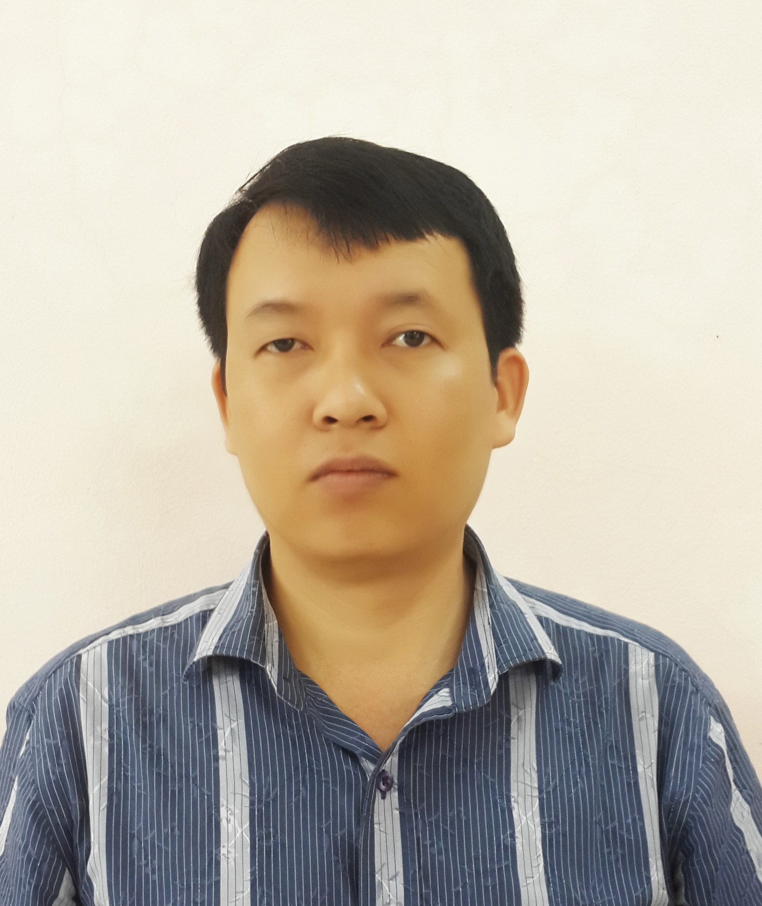
1. Name: Thanh Fist Name: Luong Huu
2. Date of birth: December 22,1972 Place of birth: Ha Noi, Viet Nam
3. Nationality: Vietnamese
4.Office: Environmental Biology Department, Institute for Agricultural Environment, Me Tri – Dai Mo -Tu Liem- Ha Noi, Viet Nam
Tel. 84.437893273, Fax. 84.437893277
Mail: huuthanhvasi@gmail.com
5. Education:
1994-1998: Biotechnology (Eng); Hanoi Open University, Viet Nam
2004-2006: Postgraduated on Biotechnology (MSc); Hanoi Technology University, Viet Nam
2009-2012: Doctor of Biotechnology; Hanoi Technology University, Viet Nam
6. International training

2006: Traning course on Biofertilizer Application Technology in Agriculture – Guangzhou, China.
2009: Symbiotic nitrogen fixation, Umea University, Sweden

7. Professional occupation:
1/2000 – 9/2004: Microbiology Department – Viet Nam Agriculture Science Institute.
9/2004 – 12/2005: Department of Physiology, biochemistry and agricutural product quality-Viet Nam Agriculture Science Institute.
1/2006 – 7/2008: Microbiology Department – Soils and Fertilizers Institute, Viet Nam Academy of Agriculture Science.
8/2008 up to now: Environmental Biology Department, Institute for Agricultural Environment - Viet Nam Academy of Agriculture Science.
8. Main activities:
Research on:
- Microoganism.
- Organic manure and biofertilizer, N-fixation for legume and nonlegume crops, P-solubilizing and plan growth promoting microorganisms.
- Composting.
- Water waste treatment, biogas.
Professional experience:
Project Coordinator:
- National project: Study on produce and apply multistrain biofertilizer for agricultural, industrial crops and forestry trees (2005-2007)
- National project: Study on the microbial production use for treatment of waste's cassava starch processing (2010-2012)
- National project: Completing the microbial production technology that use for treatment of waste's cassava starch processing (2014-2016)
Senior research in the projects:
- National project for research and development of multistrain biofertilizer for agricultural, industrial crops and forestry trees (2001-2004).
- Efficient nutrient use in rice production in Vietnam achieved using inoculant biofertilisers (Aciar Project 2005-2007).
- Study on rapid treatment livestock’s waste by microbial inoculants (2008-2010).
- National project for research and development of biofertilizer for biological control of plan diseases (2006 - 2008).
- Research and development of biological solutions to improve grey degraded soil (2009-2012).
- Jica project for Climate Change Mitigation Potentials in Vietnam Agriculture (2010-2011).
- National project for research and development of microbial inoculants for livestock’s waste treatment (2012-2013).
9. Hobby: Swimming, reading

Hanoi, May 9, 2014

Luong Huu Thanh

